Name: Shivang Chaurasia
Roll No: 16
Registration No: 12316885
Outdoor Activity: User Mental Model & Behaviour Study
Objective: To observe how users interact with machines/equipment on the university campus and identify gaps between their expected interaction (mental model) and the actual interaction.
Machine 1: Document Verification / Information Kiosk:
Location: University Campus, Kapurthala, Punjab
Machine: Touchscreen Information / Document Verification Kiosk
User Expectation:
The user expects the kiosk to provide a simple and straightforward way to access the required service. After selecting an option, the user expects clear guidance about what to do next.
User Behaviour:
The user first looks through the different options displayed on the touchscreen and then selects the required option. The presence of multiple options requires the user to examine and understand the available choices before proceeding.
Mental Model Mismatch:
The user expects a simple "select the required service and proceed" interaction. However, the kiosk presents several service options together, requiring the user to first understand what each option means and determine which one is relevant.
Expected: Select service → Get clear next step
Actual: Examine multiple options → Interpret them → Select the appropriate option
Problem:
The interface presents multiple choices without making the starting point or preferred action immediately obvious. This can increase the user's cognitive effort, especially for a first-time user.
Improvement:
- Use clearer, action-oriented labels for the options.
- Introduce a guided, step-by-step flow that asks the user what they want to accomplish before presenting detailed options.

Evidence:
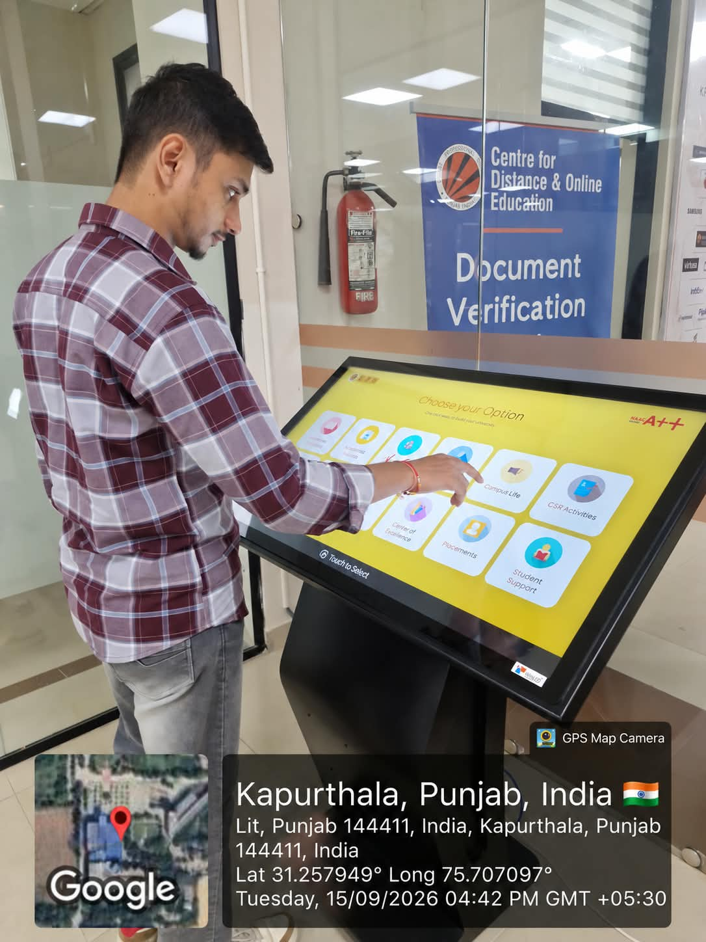
Photo 1: User interacting with the touchscreen kiosk.

Machine 2: Go-Grab Smart Vending Machine
Location: University Campus, Kapurthala, Punjab
Machine: Go-Grab Smart Vending Machine
User Expectation:
The user expects the product identification on the touchscreen to correspond clearly with the physical arrangement of products in the vending machine. After selecting a product, the user should be able to easily identify the exact product and its location.
User Behaviour:
While using the vending machine, I experienced hesitation while trying to select a product. The products were physically arranged according to different shelves/rows, while the touchscreen grouped similar products together.
For example, chips were placed across different shelves in the machine, but they were grouped together on the touchscreen. Similarly, similar drinks/juices could have different numbers depending on their physical position.
Mental Model Mismatch:
The physical vending machine creates the mental model that each product/row has a corresponding identification number. However, the touchscreen uses a different grouping and numbering system.
Expected: Product number on screen → Easily locate the same product physically
Actual: Product grouping/number on screen differs from physical arrangement → User has to mentally match the product, number, and shelf location
Problem:
Inconsistent product grouping and numbering between the physical vending machine and touchscreen causes hesitation and makes it difficult for users to confidently identify the exact product they want to purchase.
Improvement:
- Use the same product number/identifier on both the touchscreen and the physical shelf.
- When a product is selected on the screen, display its exact shelf/row location, or organize the touchscreen according to the physical layout of the machine.

Evidence:
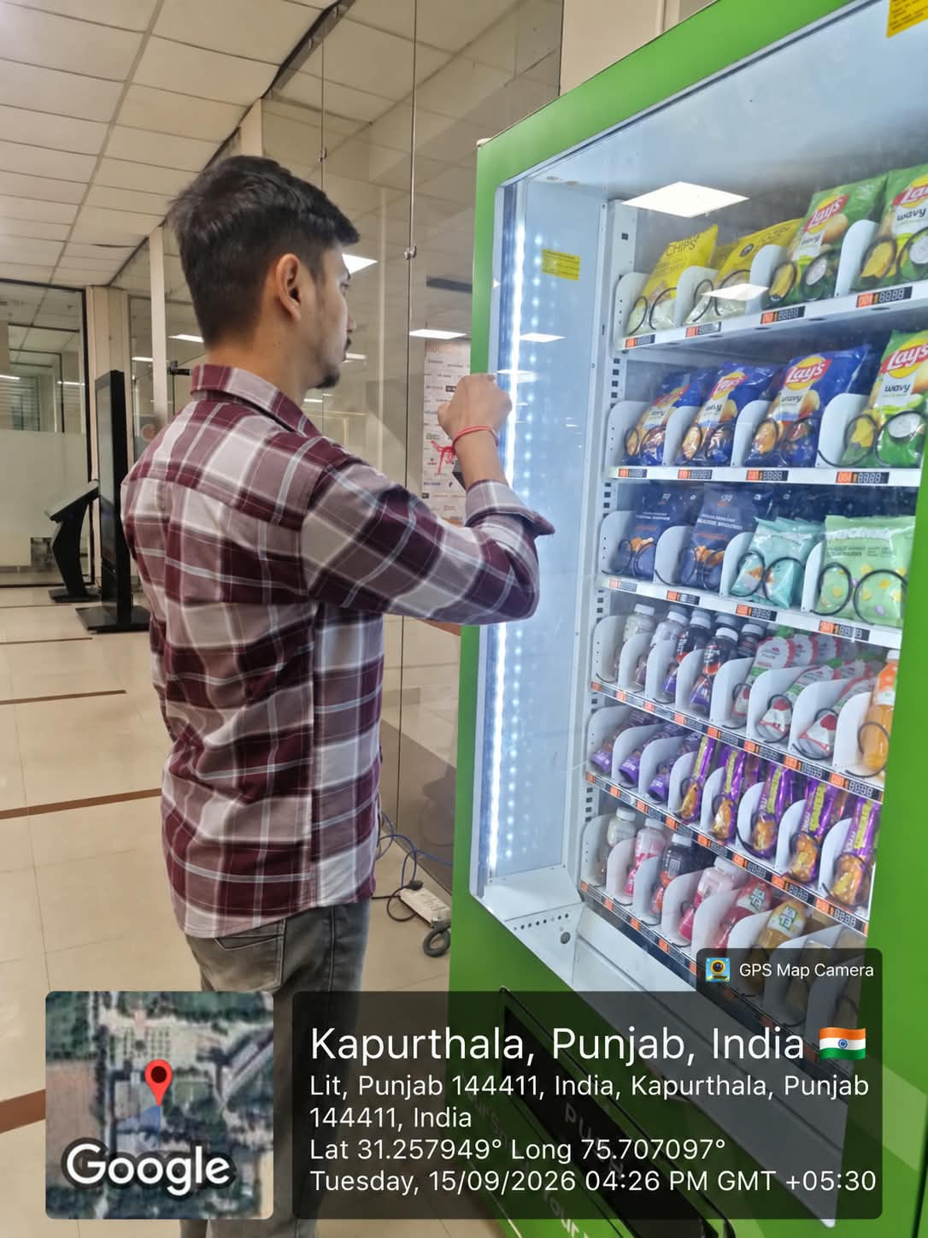
Photo 2: User examining the products inside the vending machine.

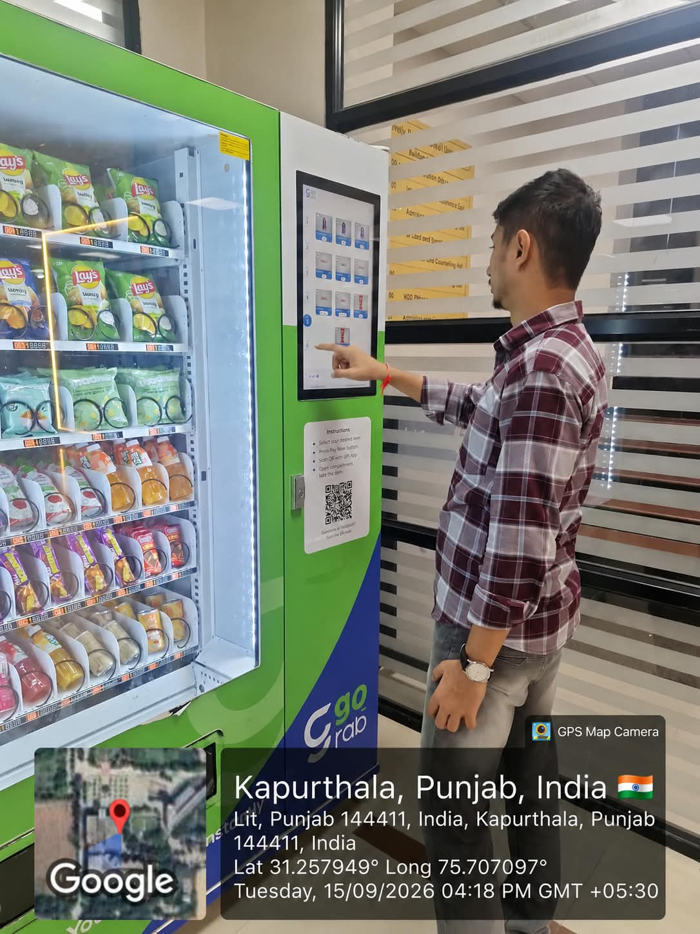
Photo 3: User interacting with the vending machine touchscreen.

Key Findings:
Machine | Main Usability Issue | Suggested Improvement
Document Verification Kiosk | Multiple choices require users to interpret the options before knowing what to select. | Use clearer labels and a guided step-by-step flow.
Go-Grab Vending Machine | Digital product grouping/numbering does not match the physical product arrangement, causing hesitation. | Match digital and physical numbering and show the exact shelf/row location.

Conclusion:
The study shows that users rely on their mental models to predict how a machine should work. When the interface does not match that mental model, users may hesitate or need additional effort to understand the correct action. The vending machine particularly demonstrates this issue because its digital organization does not match its physical organization, creating an avoidable gap between what the user expects and what the system actually presents.

